November 29, 2014 2:18 am JST
Energy-hungry Asia presents new opportunities
Photo: Marubeni is involved in power projects around the world.
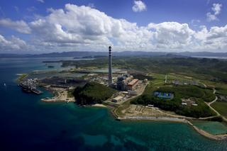
TOKYO -- Economic growth in Asia is sharply boosting demand for energy in the region, opening new doors for big Japanese general trading firms, which have plenty of experience and know-how in the field from years of bringing energy to their home country.
Marubeni plans to build a cutting-edge coal-fired power plant in southern Myanmar, near Thailand. Its output capacity of 2 million kilowatts may be overkill for Myanmar's current needs, but the Japanese trading company is not just focusing on Myanmar. Across the boarder, Thailand is suffering from power shortages.
"We can hold down construction costs such as for labor and land compared with building a power plant in Thailand," said Moroo Shino, deputy general manager at Marubeni's Overseas Power Project Department II.
The project has the blessings of both Thailand's state-owned energy company PTT and Myanmar's Ministry of Electric Power. The power plant is slated to start generating power in 2020.
Reaching deep into Asia: Marubeni's electric power business is the biggest among the Japanese trading firms. Encompassing 23 countries, the company's power generating capacity according to its stakes in projects totals more than 10 million kilowatts, exceeding the scale of Shikoku Electric Power or Hokuriku Electric Power. Asia accounts for 40% of Marubeni's electric power business.
Most of the company's power generation operations cover a single country. This is only natural because the type of power needed and regulations differ from one nation to another. But Marubeni has decided to pursue the strategy of looking for ways to serve multiple countries from a single operation to accelerate expansion.
"We will connect power supply networks all over Asia," Shino says.
At the same time, the company is also looking to "cultivate the South American and African markets," according to Chairman Teruo Asada.
This is partly because competition in Asia is intensifying, as the region is the main focus of Japan's public-private efforts to boost infrastructure exports.
For example, Mitsubishi is considering building a power plant in Myanmar. Mitsui has decided to take part in construction and operation of an advanced coal-fired power plant in Malaysia.
Chances everywhere: But there are many more opportunities in other energy segments in Asia, since the market dynamics are shifting dramatically.
Liquefied natural gas is a case in point. With Indonesia and Malaysia morphing from major exporters into importers, and Singapore moving toward boosting imports, Asia needs to create a new market for LNG, an official at a Mitsui unit said.
The trading firm is exploring opportunities for natural-gas-fired power plants in Asia because it expects the region's focus to shift from coal-fired plants to LNG-fueled power stations.
For the Japanese trading firms, selling natural gas and cogeneration systems, and converting factories and ships to run on natural gas instead of oil, are just a few examples of what they could offer the region. (Nikkei)

November 29, 2014 5:50 am JST
Recovery uneven as tax hike curtails spending
TOKYO -- Japanese production edged higher in October, but the growth was largely limited to a handful of industries, shows a preliminary report from the government.
The seasonally adjusted production index rose 0.2% from September, better than the 0.1% decline estimated a month ago, according to the industry ministry.
The increase was driven by electronics parts makers, chipmaking equipment suppliers and others benefiting from the expanded production of smartphones in Asia. The subindex covering electronics and devices rose 1.6%, with the industrial machinery sector climbing 4.4%.
Meanwhile, automakers and other manufacturers weighed down by slower domestic consumption have not ramped up output. The index for passenger car production slid 4%.
Many consumers rushed to buy cars before the nation's sales tax went up to 8% in April and subsequently tightened their purse strings. Inventories that had fattened considerably after the tax hike shrank 10% on the month in October, but still stood at the same level as in June.
Many automakers have shifted production out of Japan, so fewer vehicles are being shipped to North America than a year ago. Output for export is unlikely to grow much either.
Output increased for six of 15 industry sectors covered in the report, while production declined for the other nine.
Spending by households of at least two people shrank 4% on the year in real terms in October, according to the internal affairs ministry. Spending on durable goods, such as cars and appliances, was down 23.1% from a year earlier.
Production growth moving forward will depend on such factors as whether consumer sentiment improves on the back of lower gasoline prices. (Nikkei)

December 1, 2014 6:24 pm JST
Moody's downgrades Japan
BANGKOK -- Moody's Investors Service downgraded Japan's sovereign debt rating on Monday. The ratings agency is dropping Japan one notch from Aa3 to A1. The outlook remains stable, Moody's said.
In a report published on Monday, Moody's mentioned three major drivers for the downgrade. The first was the "heightened uncertainty over reaching fiscal targets and containing debt." The agency poses a question as to "whether policymakers can overcome the tensions inherent in promoting growth while simultaneously stabilizing and reversing the rising debt trajectory."
The second driver for the downgrade is the "economic growth policy uncertainties and challenges in ending deflation." Uncertainty over the government's ability to "fire" the so-called "third arrow" of Abenomics, structural reform, is under question. "Some indicators suggest a pick-up in economic activity over the past year, but potential economic growth remains low," Moody's wrote.
The third one is the "erosion of policy effectiveness and credibility that could undermine debt affordability." Moody's explains that last driver "is the potential implications of the first two drivers."
However, Moody's added that "even with the very significant debt burden, we believe that Japan exhibits only 'Low' susceptibility to event risk," given its large and diverse economy and a "marked home bias on the part of resident investors providing a strong funding base -- domestic investors retain a marked preference for government bonds."

December 2, 2014 10:39 am JST
Inflation-adjusted wages continue falling in Japan
TOKYO-- Wages for workers adjusted for inflation dropped 2.8 percent in October in Japan, marking the 16th consecutive month of decline, government data showed Tuesday.
Wages stood at 267,935 yen per worker, up 0.5 percent from a year earlier if the impact of consumer price hikes is excluded, the Ministry of Health, Labor and Welfare said in its monthly preliminary report on wages and overtime trends at businesses hiring five employees or more.
It was the eighth month in a row that nominal wages climbed, due to pay increases after spring labor negotiations and the strong labor market.
The growth in nominal wages, however, was outpaced by inflation spurred by the consumption tax hike in April and the falling value of the yen, which generally makes imported products more expensive.
Basic wages edged up 0.4 percent to 242,370 yen. While wages in this category increased 0.5 percent for full-time workers, they dropped 0.3 percent for part-timers.
Overtime payments inched up 0.4 percent to 19,673 yen, slower than 1.9 percent in the previous month as demand for extra hours stumbled. Non-recurring wages such as bonus payments grew 6 percent to 5,892 yen. (Kyodo)

December 2, 2014 1:00 pm JST
Capital investment fails to fire in Japan
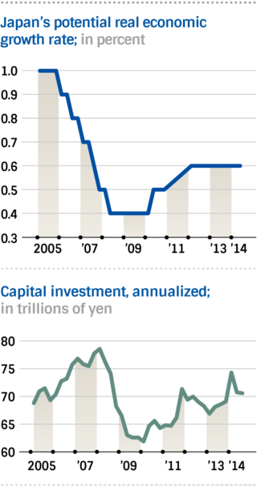
TOKYO -- With the Dec. 14 general election for the House of Representatives widely seen as a referendum on ''Abenomics,'' one of the cornerstones of the prime minister's economic policy, capital investment, has failed to fire.
Shinzo Abe's economic agenda aims to end prolonged deflation and revitalize the Japanese economy with ''three arrows'' -- bold monetary easing, a flexible fiscal policy and a growth strategy designed to encourage private investment.
The virtuous cycle of a weaker yen, record corporate profits, increased employment and wage rises, is now returning after two years of Abenomics. An executive at a major electronics company said, ''We can aim for another record profit in the next financial year.''
However, the Japanese economy's potential growth rate remains mired in the doldrums and capital investment in the country has so far not increased by as much as expected.

The slow progress of Prime Minister Abe's growth strategy is a factor behind his decision to delay an additional consumption tax rise.

Toray's big break:
Photo: Toray Industries has secured a 1 trillion yen contract with Boeing. Toray is building a new 100 billion yen ($834 million) plant in the U.S. to supply carbon fiber to the aircraft maker.
Some Japanese government officials heaved a sigh of grief when they heard Toray Industries is building a new 100 billion yen ($834 million) plant in the U.S. to supply carbon fiber to aircraft maker Boeing.
Toray announced on Nov. 17 that it has secured a 1 trillion yen contract with the U.S. company.
Toray President Akihiro Nikkaku said, ''We will strengthen our relations with Boeing with an eye on the next 40 years.''
The company started researching carbon fiber in the 1970s. An official at the Ministry of Economy, Trade and Industry said it was ''frustrating'' to see Toray set up a new plant in the U.S. for technology it spent 40 years developing in Japan.
Overseas output up: Vehicles are Japan's main export product, accounting for 20% of the country's overall exports in terms of value.
The overseas production ratio of the Japanese auto industry surged from 50% to 65% following the global financial crisis, triggered by the collapse of Lehman Brothers in the autumn of 2008.
The industry shifted more of its production abroad to cope with a sharp rise in the value of the yen. This trend has remained unchanged even though the yen has reversed course and depreciated significantly.
In the past year alone, production of about 600,000 vehicles per year has been moved from Japan to North America and elsewhere.
Warren Buffett's move: While the pace of investment by domestic companies is slow, there is also a lingering awareness among foreign business people and investors that ''investment in Japan runs counter to companies' enhanced management efficiency,'' as one of them put it.
In October, Toyota Motor met with its U.S. dealers in California and Warren Buffett, a prominent investor, also attended.
Buffett's investment company recently purchased a major U.S. car dealership chain. Out of the U.S. dealerships selling Toyota cars, 5% are under Buffett's chain.
There is a widespread view on stock markets that since Toyota faces inefficiencies in Japan due to high corporate taxes and energy costs, Buffett ''has come up with a method to directly invest in Toyota's cash-cow U.S. operations (instead of Toyota itself),'' as one market player put it.
Abe's international pledge: Prime Minister Abe delivered a speech at the World Economic Forum in Davos, Switzerland in January this year, in which he vowed to make Japan one of ''the most business-friendly places in the world''
The Abe government then revised its growth strategy in June. The revised strategy includes, among other things, implementing corporate tax cuts and tackling ''rock-hard'' regulations related to employment, medical care and agriculture.
However, the Abe government has yet to present a clear road map for those measures.
The revised growth strategy calls for lowering effective corporate tax rates -- which include both national and local levies -- below 30% within several years from next fiscal year. However, it is still unclear specifically how much the tax rates will be cut and by when.
As a pillar of its growth strategy, the Abe government introduced a ''national strategic special zone'' scheme to ease regulations in zones such as in the agricultural and medical care sectors.
National strategic special zone-related bills were submitted to the last extraordinary session of the Diet, Japan's parliament, to promote deregulation, but they were killed as Abe dissolved the House of Representatives for the general election.
Monetary and fiscal policies have had an immediate effect on the economy. But the success or failure of the growth strategy depends on whether it will encourage long-term investment.
The Abe government needs to make it clear as soon as possible how it plans to make Japan an attractive country for companies to invest in. Japanese companies have technologies with the potential to generate huge investments, such as induced pluripotent stem (iPS) cells, a magnetically-levitated train and robots for medical use. Now is Japan's moment of truth if it wants to capitalize on these seeds of growth.

December 2, 2014 1:25 pm JST
Opposition parties trying to work together
Photo: Campaigning for the Dec. 14 general election officially kicks off. Crowds of voters listen to a candidate on Tuesday morning in Shinjuku, central Tokyo.
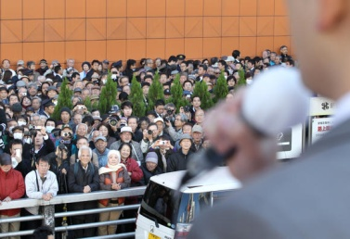
TOKYO -- Japan election campaigns officially started Tuesday, 12 days before the general election. Prime Minister Shinzo Abe is trying to make the vote about his economic policy project, known as Abenomics.
Parties will compete for 475 seats -- 295 single-seat constituencies and 11 proportional representation blocs nationwide. Voting and counting takes place Dec. 14. Candidates have to tender their application by 5 p.m. Tuesday.
The ruling Liberal Democratic Party won the last lower house election in December 2012, recapturing power from the Democratic Party of Japan. As of 1:20 p.m., 1,188 candidates had filed their applications: 956 candidates for single-seat constituencies and 841 under the proportional representation vote. Some candidates are running for both.
Abe, who is also the LDP president, aims to win 238 seats, a lower-house majority, for the LDP and junior coalition partner Komeito.
Of 295 single-seat constituencies, the ruling parties have fielded candidates in 292 constituencies. Opposition parties, excluding the Japanese Communist Party, have unified their candidates in 190 constituencies. They are attempting to form a united front against the ruling parties. In 122 constituencies, the ruling parties will face off against the largest opposition party DPJ.
Nevertheless, opposition parties still compete against each other in 67 districts, and their policy platforms are not unified.
In the 2012 general election, the LDP, DPJ and the third block, including the now-disbanded Japan Restoration Party, competed in about 200 constituencies. As this three-block race led to a major win for the ruling parties, opposition parties have tried to reduce the number of constituencies in which their candidates compete against each other, to the benefit of the ruling parties.
Ruling and opposition candidates will face off in DPJ-stronghold constituencies, such as Hokkaido and Aichi prefectures. The DPJ and other opposition parties have come to agreements on candidates in these places. (Nikkei)

December 4, 2014 5:38 am JST
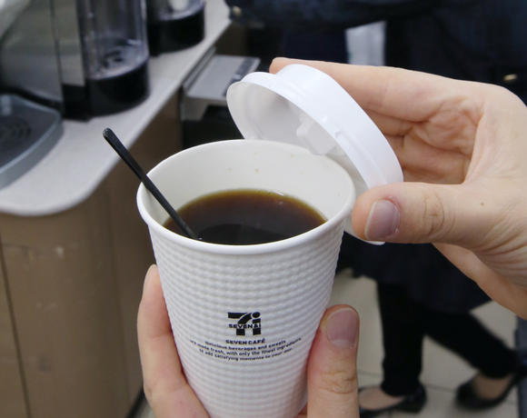
Strong companies key to lifting Japanese economy
Photo: An annual 700 million cups of fresh-brewed coffee are sold at Seven-Eleven Japan convenience stores.
TOKYO -- Corporate profits are approaching a historic high in Japan on the stellar performance of a few exporters, but they must now find ways to transfer that wealth to weaker domestic-oriented companies and feed economic growth on a wider scale.
Pretax profits among publicly traded Japanese companies could top records this fiscal year for the first time in seven years, in large part thanks to the weak yen and the booming new-car market in North America. Fuji Heavy Industries projects sales there to grow 16%, more than the projected market growth rate, and is expecting profits to reach all-time highs.
Its Subaru brand has been so popular that some dealerships had to bring in their employees' cars to fill their showrooms, after even the models on display had been sold. When President Yasuyuki Yoshinaga visited the U.S., local outlets complained that they were not there to sell an empty showroom.
Listed companies bolstered pretax profits by a combined 1.5 trillion yen ($12.4 billion) just in the April-September half. But over 70% of that boost came from 10 companies that fully benefited from the weak yen and the U.S. economic recovery, such as automakers and electronics companies. Of the roughly 1,500 listed businesses, 42% actually saw profits shrink. Domestic consumption has yet to recover from the consumption tax hike in April. Business was slow at electronics retailer Nojima's main store in Sagamihara, near Tokyo, late last month. "Prices have risen a lot after the tax hike," a customer complained.
The situation is even more dire in small-town Japan, which has benefited less from Abenomics. Mr Max, a discount store chain based in the Kyushu region of southern Japan, fell into the red in the April-September half. It has cut prices even further after the tax hike, but the response has been underwhelming. There's only so much it can do amid soaring labor and distribution costs, a company official laments.
Even seemingly robust companies are not on solid ground. Suzuki Motor and Mitsubishi Motors actually saw operating profits shrink for the first time in two years in the July-September quarter. Operating profits at most listed companies have also stayed flat.
The key to improving the situation may be for stronger companies to share their wealth with others within their spheres of influence. Toyota Motor is eyeing a 2 trillion yen net profit this fiscal year -- a record for any Japanese company. It has decided not to demand that its suppliers cut prices, which would help the massive profit trickle down.
"They made a smart decision to put off cutting costs," said Masafumi Muro, president of autoparts maker Muro. "It helps a lot that we don't have to engage in price negotiations," Meiwa Industry President Toshihiko Shimizu also said. Toyota is the main client of both parts makers.
And Seven & i Holdings is taking the coffee market by storm in collaboration with 10 other companies. It now sells 700 million cups of fresh-brewed coffee a year at its Seven-Eleven Japan convenience store chain. Fuji Electric, which produces the coffee makers, Ajinomoto General Foods, which roasts the beans, and Mitsui & Co., which procures the beans, all benefit from the success.
Strong corporations tend to attract profits. That money, once it trickles down to clients and suppliers, could boost investment and employment and underpin long-term growth across the entire Japanese economy. (Nikkei)

