Nissin Foods de Mexico S.A. De C.V

renews meal ready to eat to get Mexican market

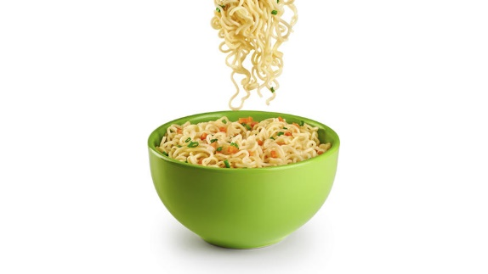
"This will be the first product launches into a new category” said Miss Sandra Gazca, Marketing Manager in Mexico and Central America of Nissin Foods de Mexico S.A. de C.V.

The instant soup that the brand is going to launch later this year is focused on working people aged 26 to 35 years old, that do not have time to prepare their meals, plus seeking sophisticated flavors.

The product will be imported from the plant in California, United States, because of the packaging, which is 100% made of paper with a technology called eco-style patented by Nissin Foods de Mexico S.A. De C.V. worldwide. The container carries a paper layer is completely biodegradable in comparison with the propylene glass previously handled.

For years, Nissin Foods de Mexico S.A. De C.V. production in America was in United States and Brazil. It was until 2005 that the company inaugurated its first plant in Mexico, in order to cover the demand from the country to Panama. The most important competitor is the Mexican company “Maruchan” which entered into the country in 1995.

Nissin Foods de Mexico S.A. De C.V. is evaluating investments in Mexico to have a new plant to produce the new line of products.

In the country where millions of people eat away from home with limited budget, it is not difficult to explain why the market of instant soups and fast food (Ready to eat) have much room for growth.

"This is the beginning of changes that Nissin Foods de Mexico S.A. De C.V. is making, so we started with a Gourmet product, but later we will launch other products", said marketing manager.

The market for food ready to eat in Mexico has a value of usd $413. 5 million and it has grown by 10% over the past five years, according to Euromonitor. The main companies involved in this category are Sigma Alimentos, Bachoco, Unilever, Moderna and Nestle.

"A change that consumers are interested is the environmental sustainability; we should expect that the introduction of eco-style container in Mexico will be an important differentiator with respect to its main competitor and quality in the product.”, said the manager of the company.

Source:
- Expansion

http://expansion.mx/empresas/2016/10/12/nissin-foods-se-renueva-para-ganar-mercado-en-comida-instantanea

