Coconut fiber is used to make construction material
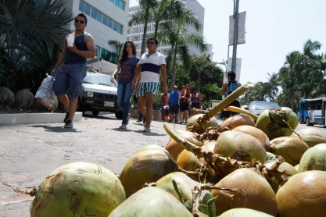

In order to create an alternative method of construction, a group of students and professors of a Technological Institute in Mexico, developed a prototype of folded cover based on fiber of coconut and polyester resin.
The experimental study search to test the structural strength of the roof to be used later in housing construction, Mr. José Ricardo Moreno Peña, doctor in architecture, said.
"We are looking to take advantage of these natural fibers, we observe that they have great advantages when they are used in construction of roofs; In addition you can use recycled paper and coconut fiber", commented Moreno Peña.
In an interview with the Agency of National Council of Science and Technology, Mr. Moreno Peña said that they have increased the resistance of the material to almost 90 kilograms per square centimeter.

The prototype, he added, aims to be a sustainable model, because it seeks to add value to coconut, which, currently, is wasted or burned as fuel, polluting the environment.

The polyester resin is used to paste the elements, however, the specialist did not rule out the idea of ​​using some cement for the research.
On the other hand, the student of architecture, Mr. Joel Vargas Montes affirmed that the purpose of the cover is to give safe alternatives of construction for people.
At the moment, scientists work with the technical resistance of coconut fiber to give way to the thermal resistance of the same materials and comfort.

Source:

- La Jornada
http://www.jornada.unam.mx/ultimas/2016/11/22/estudiantes-usan-fibra-de-coco-para-crear-material-de-construccion

