Miniso will open stores in Mexico’s malls
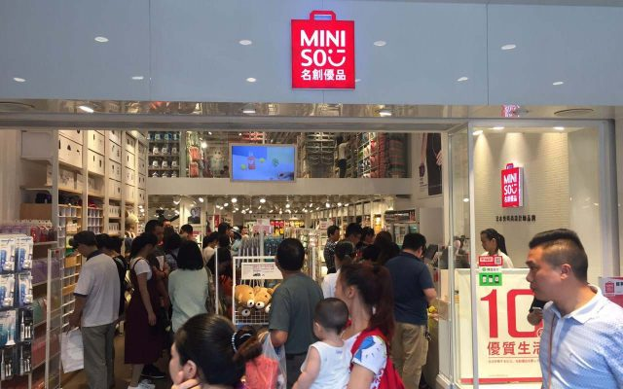

Nowadays, analysts recommend Mexico strengthens bilateral relations with other countries, the Japanese brand Miniso, important company of marketing household, health and technological products is ready to open stores in the most important malls in Mexico.

In 2017, Miniso will invest us$ 3 million confirmed Mr. Eduardo Tishman,

Director of the brand in Mexico.

"We hope to inaugurate 10 stores in Mexico City. In 2018, we plan expanding to other important cities in the country such as Guadalajara, Monterrey and Cancun", the executive said in an interview.

Miniso will sell around 5,000 products from seven different lines, including seasonal items, household, health and beauty, jewelry, bags and accessories, technology and clothing.

The company sells daily use products, 60% of them will have a value below to us$ 5.00 and 40% will be below to us$ 2.00.

“Considering the economic scenario, affordable prices can give us a lot of success in Mexico", Mr. Eduardo Tishman said.

In 2015, the commercial chain billed more than us$ 750 million. Miniso has presence in 20 important cities in Asia and it has franchises in other 40 countries, including Mexico.

Some stores of the brand are in United States, Canada, Russia, Singapore, Dubai, Korea, Malaysia, China and Bangladesh. The company expects expanding to Latin America.

In Mexico, the company plans to sell online as well next year, with the same amount of products as in the stores.

Source:

- Forbes
http://www.forbes.com.mx/japonesa-miniso-alista-su-llegada-a-los-centros-comerciales-de-mexico/#gs.2wn4fUs

